**Aptitude Test : 1 Marks, 20 Minutes**

1. Find the number of triangles in the given figure.

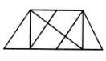

a) 8 b) 10 c)12 d)14

2. Find the odd man out. ***3, 5, 11, 14, 17, 21***

a) 3 b) 14 c) 17 d)11

3 .Rearrange the words according to the scale

**A. Moon B. Sun C. Mission D. Space**

i) CDBA ii) DCBA iii) DBAC iv)None

***4. The largest country in the world by geographical area is_?***

a) Russia b) USA c) Australia d)China

5. Which letter represents north-east?

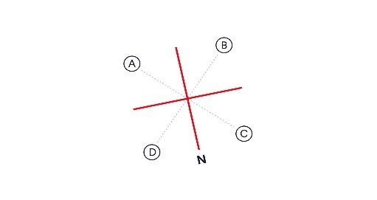

i) A ii) B iii) C iv)D

6. What is missing from the Hexagon?



………………………………………………………………………..

7. **Since the beginning of history_____________**

P: have managed to catch

Q: The Eskimos and Red Indians

R: by a very difficult method

S: a few specimens of this aquatic animal

The Proper sequence should be:

a) QRPS b) SQPR c) SQRP d)QPSR e) None of the Above

8. Which is correct? “Penguins flies” or “A Penguin flies.”

a) Penguins flies b) A Penguin flies c) None d)Both

9. I have three apples. If you take away two from me, how many do you have?

a) 1 b) 2 c) 3 d)0

10. What colour should you avoid painting your car if you don’t want it to overheat quickly on a sunny day.

a) Bright White b) Black c) Silver d)Yellow

**bonus.** If you were standing in the middle of the Republic of Sudan, facing west, and then turned left, which country would be located directly north?

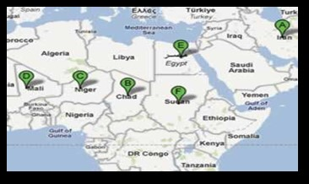

a) Egypt b) Chad c) Niger d)Iran

Name of Applicant :.................................................................... Date:................................. Score:......